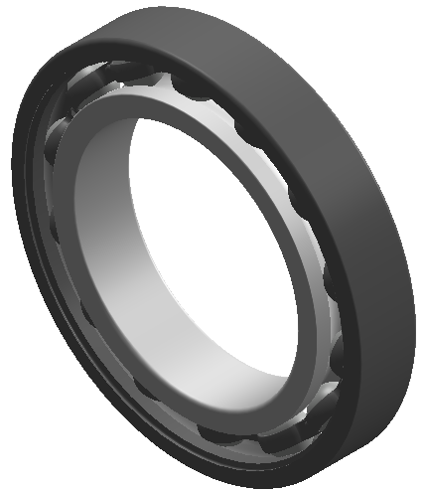 Deep groove ball ball bearing diagram

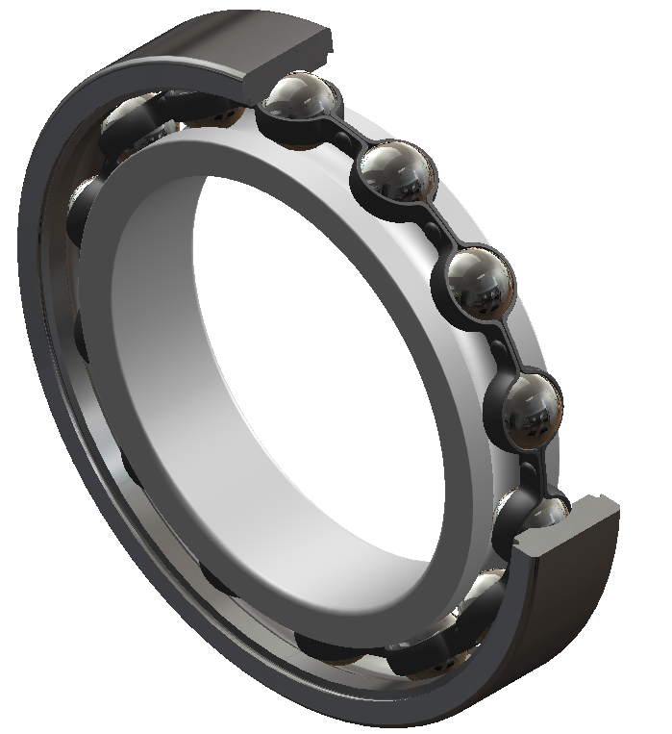Deep groove ball bearing section view
TPI bearing model form
Type No. | d | D | B
6800 | 10 | 19 | 5
6800ZZ | 10 | 19 | 5
6800LLB | 10 | 19 | 5
6800LLU | 10 | 19 | 5
6900 | 10 | 22 | 6
6900ZZ | 10 | 22 | 6
6900LLB | 10 | 22 | 6
6900LLU | 10 | 22 | 6
6000 | 10 | 26 | 8
6000ZZ | 10 | 26 | 8
6000LLB | 10 | 26 | 8
6000LLH | 10 | 26 | 8
6000LLU | 10 | 26 | 8
6200 | 10 | 30 | 9
6200ZZ | 10 | 30 | 9
6200LLB | 10 | 30 | 9
6200LLH | 10 | 30 | 9
6200LLU | 10 | 30 | 9
6300 | 10 | 35 | 11
6300ZZ | 10 | 35 | 11
6300LLB | 10 | 35 | 11
6300LLH | 10 | 35 | 11
6300LLU | 10 | 35 | 11
6801 | 12 | 21 | 5
6801ZZ | 12 | 21 | 5
6801LLB | 12 | 21 | 5
6801LLU | 12 | 21 | 5
6901 | 12 | 24 | 6
6901ZZ | 12 | 24 | 6
6901LLB | 12 | 24 | 6
16001 | 12 | 28 | 7
6001 | 12 | 28 | 8
6001ZZ | 12 | 28 | 8
6001LLB | 12 | 28 | 8
6001LLH | 12 | 28 | 8
6001LLU | 12 | 28 | 8
6201 | 12 | 32 | 10
6201ZZ | 12 | 32 | 10
6201LLB | 12 | 32 | 10
6201LLH | 12 | 32 | 10
6201LLU | 12 | 32 | 10
6301 | 12 | 37 | 12
6301ZZ | 12 | 37 | 12
6301LLB | 12 | 37 | 12
6301LLH | 12 | 37 | 12
6301LLU | 12 | 37 | 12
6802 | 15 | 24 | 5
6802ZZ | 15 | 24 | 5
6802LLB | 15 | 24 | 5
6802LLU | 15 | 24 | 5
6902 | 15 | 28 | 7
6902ZZ | 15 | 28 | 7
6902LLB | 15 | 28 | 7
6902LLU | 15 | 28 | 7
16002 | 15 | 32 | 8
6002 | 15 | 32 | 9
6002ZZ | 15 | 32 | 9
6002LLB | 15 | 32 | 9
6002LLH | 15 | 32 | 9
6002LLU | 15 | 32 | 9
6202 | 15 | 35 | 11
6202ZZ | 15 | 35 | 11
6202LLB | 15 | 35 | 11
6202LLH | 15 | 35 | 11
6202LLU | 15 | 35 | 11
6302 | 15 | 42 | 13
6302ZZ | 15 | 42 | 13
6302LLB | 15 | 42 | 13
6302LLH | 15 | 42 | 13
6302LLU | 15 | 42 | 13
6803 | 17 | 26 | 5
6803ZZ | 17 | 26 | 5
6803LLB | 17 | 26 | 5
6803LLU | 17 | 26 | 5
6903 | 17 | 30 | 7
6903ZZ | 17 | 30 | 7
6903LLB | 17 | 30 | 7
6903LLU | 17 | 30 | 7
16003 | 17 | 35 | 8
6003 | 17 | 35 | 10
6003ZZ | 17 | 35 | 10
6003LLB | 17 | 35 | 10
6003LLH | 17 | 35 | 10
6003LLU | 17 | 35 | 10
6203 | 17 | 40 | 12
6203ZZ | 17 | 40 | 12
6203LLB | 17 | 40 | 12
6203LLH | 17 | 40 | 12
6203LLU | 17 | 40 | 12
6303 | 17 | 47 | 14
6303ZZ | 17 | 47 | 14
6303LLB | 17 | 47 | 14
6303LLH | 17 | 47 | 14
6303LLU | 17 | 47 | 14
6804 | 20 | 32 | 7
6804ZZ | 20 | 32 | 7
6804LLB | 20 | 32 | 7
6804LLU | 20 | 32 | 7
6904 | 20 | 37 | 9
6904ZZ | 20 | 37 | 9
6904LLB | 20 | 37 | 9
6904LLU | 20 | 37 | 9
16004 | 20 | 42 | 8
6004 | 20 | 42 | 12
6004ZZ | 20 | 42 | 12
6004LLB | 20 | 42 | 12
6004LLH | 20 | 42 | 12
6004LLU | 20 | 42 | 12
6204 | 20 | 47 | 14
6204ZZ | 20 | 47 | 14
6204LLB | 20 | 47 | 14
6204LLH | 20 | 47 | 14
6204LLU | 20 | 47 | 14
6304 | 20 | 52 | 15
6304ZZ | 20 | 52 | 15
6304LLB | 20 | 52 | 15
6304LLH | 20 | 52 | 15
6304LLU | 20 | 52 | 15
60/22 | 22 | 44 | 12
60/22ZZ | 22 | 44 | 12
60/22LLB | 22 | 44 | 12
60/22LLH | 22 | 44 | 12
60/22LLU | 22 | 44 | 12
62/22 | 22 | 50 | 14
62/22ZZ | 22 | 50 | 14
62/22LLB | 22 | 50 | 14
62/22LLH | 22 | 50 | 14
62/22LLU | 22 | 50 | 14
63/22 | 22 | 56 | 16
63/22ZZ | 22 | 56 | 16
63/22LLB | 22 | 56 | 16
63/22LLH | 22 | 56 | 16
63/22LLU | 22 | 56 | 16
6805 | 25 | 37 | 7
6805ZZ | 25 | 37 | 7
6805LLB | 25 | 37 | 7
6805LLU | 25 | 37 | 7
6905 | 25 | 42 | 9
6905ZZ | 25 | 42 | 9
6905LLB | 25 | 42 | 9
6905LLU | 25 | 42 | 9
16005 | 25 | 47 | 8
6005 | 25 | 47 | 12
6005ZZ | 25 | 47 | 12
6005LLB | 25 | 47 | 12
6005LLH | 25 | 47 | 12
6005LLU | 25 | 47 | 12
6205 | 25 | 52 | 15
6205ZZ | 25 | 52 | 15
6205LLB | 25 | 52 | 15
6205LLH | 25 | 52 | 15
6205LLU | 25 | 52 | 15
6305 | 25 | 62 | 17
6305ZZ | 25 | 62 | 17
6305LLB | 25 | 62 | 17
6305LLH | 25 | 62 | 17
6305LLU | 25 | 62 | 17
6405 | 25 | 80 | 21
60/28 | 28 | 52 | 12
60/28ZZ | 28 | 52 | 12
60/28LLB | 28 | 52 | 12
60/28LLH | 28 | 52 | 12
60/28LLU | 28 | 52 | 12
62/28 | 28 | 58 | 16
62/28ZZ | 28 | 58 | 16
62/28LLB | 28 | 58 | 16
62/228LLH | 28 | 58 | 16
62/228LLU | 28 | 58 | 16
63/28 | 28 | 68 | 18
63/28ZZ | 28 | 68 | 18
63/28LLB | 28 | 68 | 18
63/28LLH | 28 | 68 | 18
63/28LLU | 28 | 68 | 18
6806 | 30 | 42 | 7
6806ZZ | 30 | 42 | 7
6806LLB | 30 | 42 | 7
6806LLU | 30 | 42 | 7
6906 | 30 | 47 | 9
6906ZZ | 30 | 47 | 9
6906LLU | 30 | 47 | 9
16006 | 30 | 55 | 9
6006 | 30 | 55 | 13
6006ZZ | 30 | 55 | 13
6006LLB | 30 | 55 | 13
6006LLH | 30 | 55 | 13
6006LLU | 30 | 55 | 13
6206 | 30 | 62 | 16
6206ZZ | 30 | 62 | 16
6206LLB | 30 | 62 | 16
6206LLH | 30 | 62 | 16
6206LLU | 30 | 62 | 16
6306 | 30 | 72 | 19
6306ZZ | 30 | 72 | 19
6306LLB | 30 | 72 | 19
6306LLH | 30 | 72 | 19
6306LLU | 30 | 72 | 19
60/32 | 32 | 58 | 13
60/32ZZ | 32 | 58 | 13
60/32LLB | 32 | 58 | 13
60/32LLH | 32 | 58 | 13
60/32LLU | 32 | 58 | 13
62/32 | 32 | 65 | 17
62/32ZZ | 32 | 65 | 17
62/32LLB | 32 | 65 | 17
62/32LLH | 32 | 65 | 17
62/32LLU | 32 | 65 | 17
63/32 | 32 | 75 | 20
63/32ZZ | 32 | 75 | 20
63/32LLB | 32 | 75 | 20
63/32LLH | 32 | 75 | 20
63/32LLU | 32 | 75 | 20
6807 | 35 | 47 | 7
6807ZZ | 35 | 47 | 7
6807LLB | 35 | 47 | 7
6807LLU | 35 | 47 | 7
6907 | 35 | 55 | 10
6907ZZ | 35 | 55 | 10
6907LLB | 35 | 55 | 10
6907LLU | 35 | 55 | 10
16007 | 35 | 62 | 9
6007 | 35 | 62 | 14
6007ZZ | 35 | 62 | 14
6007LLB | 35 | 62 | 14
6007LLH | 35 | 62 | 14
6007LLU | 35 | 62 | 14
6207 | 35 | 72 | 17
6207ZZ | 35 | 72 | 17
6207LLB | 35 | 72 | 17
6207LLH | 35 | 72 | 17
6207LLU | 35 | 72 | 17
6307 | 35 | 80 | 21
6307ZZ | 35 | 80 | 21
6307LLB | 35 | 80 | 21
6307LLH | 35 | 80 | 21
6307LLU | 35 | 80 | 21
6808 | 40 | 52 | 7
6808ZZ | 40 | 52 | 7
6808LLB | 40 | 52 | 7
6808LLU | 40 | 52 | 7
6908 | 40 | 62 | 12
6908ZZ | 40 | 62 | 12
6908LLB | 40 | 62 | 12
6908LLU | 40 | 62 | 12
16008 | 40 | 68 | 9
6008 | 40 | 68 | 15
6008ZZ | 40 | 68 | 15
6008LLB | 40 | 68 | 15
6008LLH | 40 | 68 | 15
6008LLU | 40 | 68 | 15
6208 | 40 | 80 | 18
6208ZZ | 40 | 80 | 18
6208LLB | 40 | 80 | 18
6208LLH | 40 | 80 | 18
6208LLU | 40 | 80 | 18
6308 | 40 | 90 | 23
6308ZZ | 40 | 90 | 23
6308LLB | 40 | 90 | 23
6308LLH | 40 | 90 | 23
6308LLU | 40 | 90 | 23
6809 | 45 | 58 | 7
6809ZZ | 45 | 58 | 7
6809LLB | 45 | 58 | 7
6809LLU | 45 | 58 | 7
6909 | 45 | 68 | 12
6909ZZ | 45 | 68 | 12
6909LLB | 45 | 68 | 12
6909LLU | 45 | 68 | 12
16009 | 45 | 75 | 10
6009 | 45 | 75 | 16
6009ZZ | 45 | 75 | 16
6009LLB | 45 | 75 | 16
6009LLH | 45 | 75 | 16
6009LLU | 45 | 75 | 16
6209 | 45 | 85 | 19
6209ZZ | 45 | 85 | 19
6209LLB | 45 | 85 | 19
6209LLH | 45 | 85 | 19
6209LLU | 45 | 85 | 19
6309 | 45 | 100 | 25
6309ZZ | 45 | 100 | 25
6309LLB | 45 | 100 | 25
6309LLH | 45 | 100 | 25
6309LLU | 45 | 100 | 25
6810 | 50 | 65 | 7
6810ZZ | 50 | 65 | 7
6810LLB | 50 | 65 | 7
6810LLU | 50 | 65 | 7
6910 | 50 | 72 | 12
6910ZZ | 50 | 72 | 12
6910LLB | 50 | 72 | 12
6910LLU | 50 | 72 | 12
16010 | 50 | 80 | 10
6010 | 50 | 80 | 16
6010ZZ | 50 | 80 | 16
6010LLB | 50 | 80 | 16
6010LLH | 50 | 80 | 16
6010LLU | 50 | 80 | 16
6210 | 50 | 90 | 20
6210ZZ | 50 | 90 | 20
6210LLB | 50 | 90 | 20
6210LLH | 50 | 90 | 20
6210LLU | 50 | 90 | 20
6310 | 50 | 110 | 27
6310ZZ | 50 | 110 | 27
6310LLB | 50 | 110 | 27
6310LLH | 50 | 110 | 27
6310LLU | 50 | 110 | 27
6811 | 55 | 72 | 9
6811ZZ | 55 | 72 | 9
6811LLB | 55 | 72 | 9
6811LLU | 55 | 72 | 9
6911 | 55 | 80 | 13
6911ZZ | 55 | 50 | 13
6911LLB | 55 | 80 | 13
6911LLU | 55 | 80 | 13
16011 | 55 | 90 | 11
6011 | 55 | 90 | 18
6011ZZ | 55 | 90 | 18
6011LLB | 55 | 90 | 18
6011LLU | 55 | 90 | 18
6211 | 55 | 100 | 21
6211ZZ | 55 | 100 | 21
6211LLB | 55 | 100 | 21
6211LLU | 55 | 100 | 21
6311 | 55 | 120 | 29
6311ZZ | 55 | 120 | 29
6311LLB | 55 | 120 | 29
6311LLU | 55 | 120 | 29
6812 | 60 | 78 | 10
6812ZZ | 60 | 78 | 10
6812LLB | 60 | 78 | 10
6812LLU | 60 | 78 | 10
6912 | 60 | 85 | 13
6912ZZ | 60 | 85 | 13
6912LLB | 60 | 85 | 13
6912LLU | 60 | 85 | 13
16012 | 60 | 95 | 11
6012 | 60 | 95 | 18
6012ZZ | 60 | 95 | 18
6012LLB | 60 | 95 | 18
6012LLU | 60 | 95 | 18
6212 | 60 | 110 | 22
6212ZZ | 60 | 110 | 22
6212LLB | 60 | 110 | 22
6212LLU | 60 | 110 | 22
6312 | 60 | 130 | 31
6312ZZ | 60 | 130 | 31
6312LLB | 60 | 130 | 31
6312LLU | 60 | 130 | 31
6313 | 65 | 140 | 33
6314 | 70 | 150 | 35
AC-6201 | 12 | 32 | 10
AC-6201ZZ | 12 | 32 | 10
AC-6201LLU | 12 | 32 | 10
AC-6202 | 15 | 35 | 11
AC-6202ZZ | 15 | 35 | 11
AC-6202LLU | 15 | 35 | 11
AC-6203 | 17 | 40 | 12
AC-6203ZZ | 17 | 40 | 12
AC-6203LLU | 17 | 40 | 12
AC-6204LLB | 20 | 47 | 14
AC-6204LLU | 20 | 47 | 14
AC-6205ZZ | 25 | 52 | 15
AC-6006ZZ | 30 | 55 | 13
EC1-SC8A37 | 8 | 23 | 14
EC-608 | 8 | 22 | 7
EC-608ZZ | 8 | 22 | 7
EC-629 | 9 | 26 | 8
EC-629ZZ | 9 | 26 | 8
EC-629LLU | 9 | 26 | 8
EC-6000 | 10 | 26 | 8
EC-6000ZZ | 10 | 26 | 8
EC-6000LLU | 10 | 26 | 8
EC1-6001ZZ | 12 | 28 | 8
EC-6002 | 15 | 32 | 9
EC-6002ZZ | 15 | 32 | 9
EC-6002LLU | 15 | 32 | 9
EC1-6202 | 15 | 35 | 11
EC1-6202LLB | 15 | 35 | 11
EE3 | 9.525 | 22.225 | 5.557
R6ZZ | 9.525 | 22.225 | 7.142
EE4 | 12.7 | 28.575 | 6.35
R8U | 12.7 | 28.575 | 7.938
R8ZZ | 12.7 | 28.575 | 7.938
R8LLU | 12.7 | 28.575 | 7.938
BL206 | 30 | 62 | 16
BL207 | 35 | 72 | 17
SC727ZZ | 7 | 18 | 6
SC8A96ZZ | 8 | 18 | 6
SC0039ZZ | 10 | 26 | 8
SC00T50 | 10 | 30 | 8
SC0117LLU | 11.087 | 30 | 9
SC02T01LLB | 14 | 26 | 7
SC0284 | 15 | 42 | 11.5
SC02A17 | 15 | 35 | 8.5
SC02A51LLU | 15 | 35 | 13
SC0217ZZ | 15.875 | 34.925 | 11
SC0217LLU | 15.875 | 34.925 | 11
SC0228LLB | 15.875 | 34.925 | 11.112
SC0228LLU | 15.875 | 34.925 | 11.112
SC02A47LLU | 15.875 | 34.925 | 11
SC03A39 | 17 | 42 | 13
SC0345 | 17 | 42 | 12
SC0345LLU | 17 | 42 | 12
SC03T01LLU | 17 | 40 | 14
SC03T52LLU | 17 | 46 | 14
SC03T50LLU | 17 | 52 | 16
SC03T02LLB | 18 | 30 | 7
SC04B09 | 19.05 | 45.225 | 15.494
SC0440LLU | 19.06 | 45.224 | 15.494
SC04A31 | 20 | 47 | 12
SC04A34 | 20 | 47 | 12
SC04A47 | 20 | 52 | 12
SC04A50 | 20 | 52 | 12
SC04A86 | 22 | 56 | 15
SC632201 | 22 | 56 | 15
SC05T52 | 25 | 52 | 13
SC05T03LLB | 25 | 52 | 15
SC05T51 | 25 | 52 | 15
SC05A97 | 25 | 56 | 12
SC0563 | 25 | 62 | 12
SC06T02 | 28 | 72 | 18
SC07B37 | 35 | 72 | 14
SX6A54ZZ | 6 | 19 | 6.6
SX01A36 | 12 | 32 | 10.8
SX01T50 | 12 | 32 | 16
SX02A26ZZ | 15 | 35 | 11
SX05A81 | 27 | 47 | 8
99502 | 15.875 | 34.925 | 11
99502HV | 15.875 | 34.925 | 11
99502H | 15.875 | 34.925 | 11
626 | 6 | 19 | 6
626ZZ | 6 | 19 | 6
626LLB | 6 | 19 | 6
626LLH | 6 | 19 | 6
626LLU | 6 | 19 | 6
607 | 7 | 19 | 6
607ZZ | 7 | 19 | 6
607LLB | 7 | 19 | 6
607LLH | 7 | 19 | 6
607LLU | 7 | 19 | 6
627 | 7 | 22 | 7
627ZZ | 7 | 22 | 7
627LLB | 7 | 22 | 7
627LLU | 7 | 22 | 7
608 | 8 | 22 | 7
608ZZ | 8 | 22 | 7
608LLB | 8 | 22 | 7
608LLH | 8 | 22 | 7
608LLU | 8 | 22 | 7
628 | 8 | 24 | 8
628ZZ | 8 | 24 | 8
638 | 8 | 28 | 9
638ZZ | 8 | 28 | 9
638LLU | 8 | 28 | 9
699 | 9 | 20 | 6
699ZZ | 9 | 20 | 6
699LLB | 9 | 20 | 6
609 | 9 | 24 | 7
609ZZ | 9 | 24 | 7
609LLB | 9 | 24 | 7
609LLU | 9 | 24 | 7
629 | 9 | 26 | 8
629ZZ | 9 | 26 | 8
629LLB | 9 | 26 | 8
629LLU | 9 | 26 | 8

